Name:-Shreyasi Gidmare

PRN NO:-23070521146

**Lab 4 Final Task:**

**Customer Table (For filtering by city, name)**

|  |  |  |  |  |
| --- | --- | --- | --- | --- |
| **customer_id** | **name** | **email** | **phone** | **address** |
| 1 | Alice Johnson | alice@gmail.com | 9876543210 | New York |
| 2 | Bob Smith | bob@yahoo.com | 9123456789 | Los Angeles |
| 3 | Charlie Brown | charlie@outlook.com | 9998887776 | Chicago |
| 4 | David Miller | david@gmail.com | 8765432109 | Miami |
| 5 | Amy Adams | amy@hotmail.com | 7654321098 | New York |

**Product Table (For filtering by category, price, and stock quantity)**

|  |  |  |  |  |
| --- | --- | --- | --- | --- |
| **product_id** | **name** | **category** | **price** | **stock_quantity** |
| 1 | Milk | Dairy | 2.50 | 50 |
| 2 | Bread | Bakery | 1.80 | 30 |
| 3 | Eggs | Dairy | 3.20 | 40 |
| 4 | Chicken | Meat | 7.50 | 20 |
| 5 | Apples | Fruit | 1.20 | 60 |
| 6 | Croissant | Bakery | 2.50 | 25 |

**Employee Table (For filtering by hire date, salary)**

|  |  |  |  |  |
| --- | --- | --- | --- | --- |
| **employee_id** | **name** | **role** | **salary** | **hire_date** |
| 1 | Michael Scott | Manager | 75000.00 | 2020-05-10 |
| 2 | Jim Halpert | Cashier | 30000.00 | 2021-08-15 |
| 3 | Pam Beesly | Sales Associate | 28000.00 | 2022-02-20 |
| 4 | Dwight Schrute | Supervisor | 50000.00 | 2019-11-30 |

|  |  |  |  |  |
| --- | --- | --- | --- | --- |
| 5 | Kevin Malone | Cashier | 29000.00 | 2023-03-10 |

**Order_Details Table (For filtering orders based on date)**

|  |  |  |  |
| --- | --- | --- | --- |
| **order_id** | **customer_id** | **order_date** | **total_amount** |
| 1 | 1 | 2024-01-10 | 10.50 |
| 2 | 2 | 2024-01-12 | 15.20 |
| 3 | 3 | 2024-02-01 | 20.80 |
| 4 | 4 | 2024-02-05 | 30.00 |
| 5 | 5 | 2024-02-10 | 25.50 |

1. Write the queries to generate above tables to use as the sample for given below

Queries.

2. Find all customers **from New York or Los Angeles**.

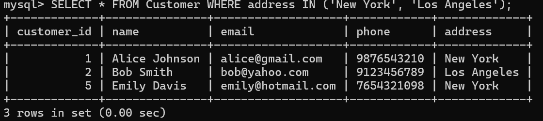

3. Retrieve products that are **Dairy or Bakery items**.

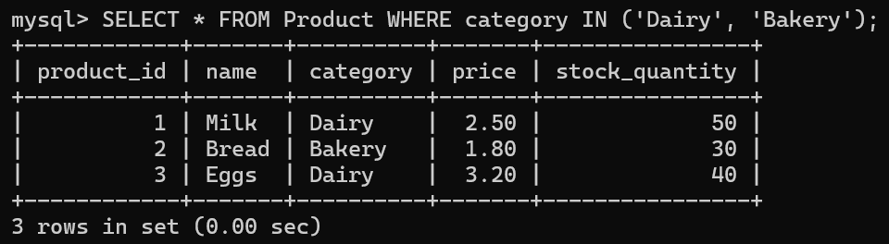

4. Find employees **hired between 2021 and 2023**.

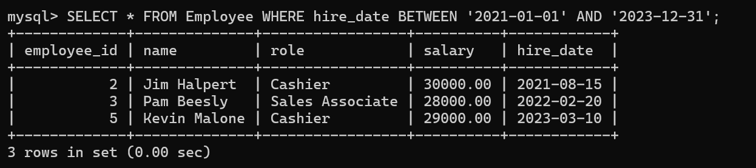

5. List customers whose **names start with ‘A’**.

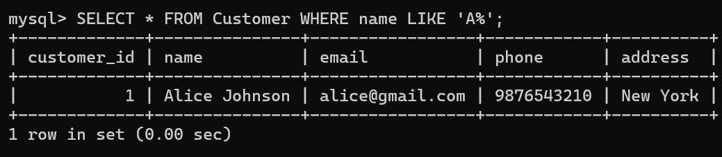

6. Retrieve orders placed in **February 2024**.

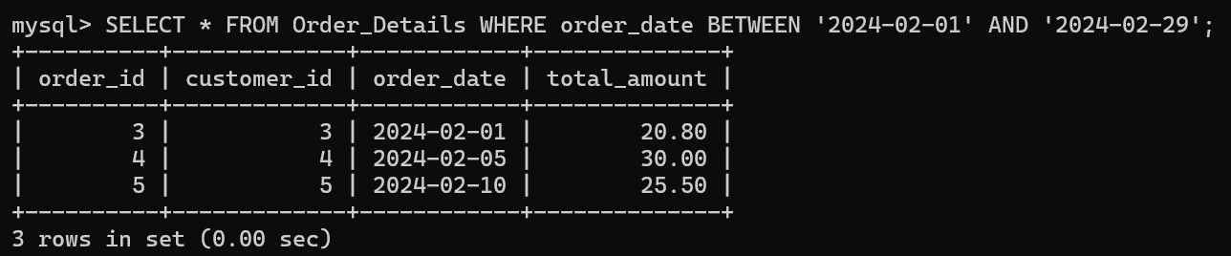

7. Count the total **number of customers**.

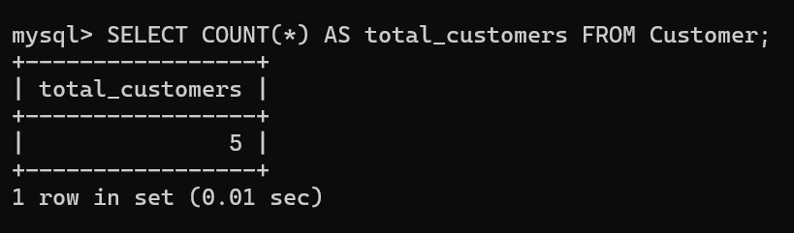

8. Find the **average product price**.

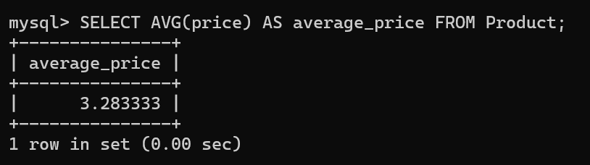

9. Get the **maximum salary of employees**.

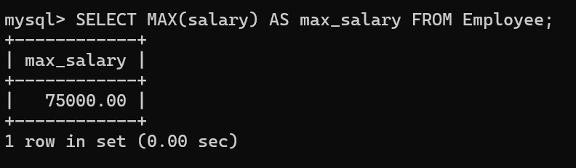

10.Retrieve the **total revenue from orders**.

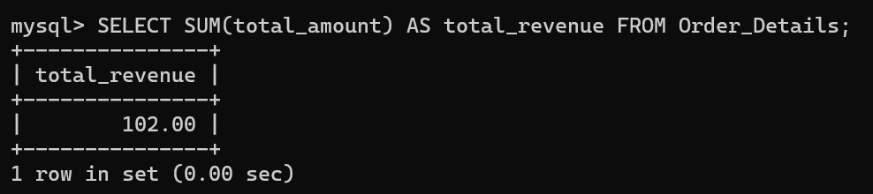

11.Find the **minimum stock quantity available**.

